The Perfect Pet
by Hillside Animal Hospital | Feb 11, 2022 | Blog
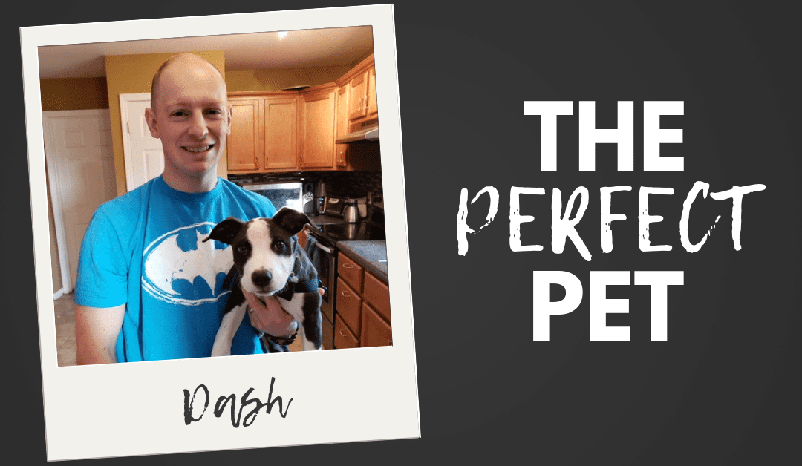
We all have an idea of our perfect pet. It may be a particular breed, a desired gender, or have a personality that fits our lifestyle. Some prefer a young animal that they can train, while others want to skip the housetraining and choose to adopt an older animal. Animals with imperfections are often looked over. They may have behavior issues or some other less desirable physical trait. We can judge books by their covers even though we should know better. Throughout my time spent at Hillside Animal Hospital, I have seen a variety of animals selected by owners for many different reasons. Some were carefully selected after researching the animal and visiting with them. Others seem to be simply selected by fate and fate is what leads me to talk about two of our newest and unique patients at the clinic.
It was a typical day at the clinic. Surgeries had finished up and patients were being cared for as they recovered. Appointments were moving along smoothly and everything was routine. Of course routine, often involves a new rescue from Gateway Pet Guardians. The rescue organization, along with others that we work with, will often go out and find strays that are living on the streets. On this day they came across a litter of puppies in an abandoned house. Upon entering the house all of the puppies scattered and ran away. All of them except for two small puppies. These puppies would have loved to run away I'm sure, but unfortunately, they could not move fast enough. This was because they couldn't fully control their back legs. Not knowing what had caused this, they were scooped up and taken to Hillside to assess why they couldn't use their legs. Upon examination, we realized that the puppies weren't injured, but most likely had a congenital defect that caused them to drag their back legs. One puppy's joints seemed to be stiff and bent in the wrong direction. We had to seriously question their quality of life. Would it be fair for them to live life partially paralyzed? Who would care for them as they grew and what hardships would they face? Thankfully, they had champions on their side. Melissa, another R.V.T and my wife, devised a plan to help the puppies out. She spoke with Lindsay, a Veterinary Assistant at the clinic and the founder of The Feral Companion, about the puppies. Lindsay had access to some of the resources that the puppies may need such as carts for when they were bigger and had a special division of her rescue for special needs animals. She also had one other critical thing that all rescue organizations need, a willing foster for the pups. Those fosters, of course, were Melissa and me. Since many rescue organizations work together to accomplish the amazing things that they do, Gateway agreed to transfer the puppies to The Feral Companion.
Now that the puppies were in our care, our minds were frantic with ideas for rehabilitating them and building/obtaining their carts. They were named Thor and Loki because we needed strong names to start their new lives out on a firm foundation. The names suited them well. Thor is the bigger of the two and would always rush in to greet you or to play, even if his legs wouldn't fully allow him. Loki is smaller in stature and is more relaxed (low-key, if you will). He also has a knack for inching close to you to give you a few kisses before nibbling on your nose. Melissa went to work and constructed two carts out of PVC pipe, padding, wheels, and duct tape. The boys now had a way to get around faster. This fun project and their story even made it on the local news! We were nervous about what their new lives might bring. We estimated that their total lifetime vet care could be close to $10,000. This is planned for routine vet care, such as annual wellness visits throughout their lives and their neuters. It also covered their carts and potential surgeries and care for their legs. These two would not only require fundraising but a very understanding home when they were adopted. They have flaws that not everyone is able to accept. All of this being said, today they have much sturdier carts and Loki has found his new home. His name is now Dash, after the little speedster from The Incredibles. His new parents have found their "Perfect Pet" in this lovable and energetic puppy. His new parents even work at an animal hospital! Melissa and I adopted Dash a few weeks after first taking him and Thor home to foster. He travels with us every day to the clinic and can see his brother, Thor on most days. Thor is still looking for his forever home and I know that he will find it. Why you ask? Because he and Dash are both the "Perfect Pet".

