Keeping Senior Pets Happy During Holiday Season
by Hillside Animal Hospital | Nov 28, 2023 | Blog
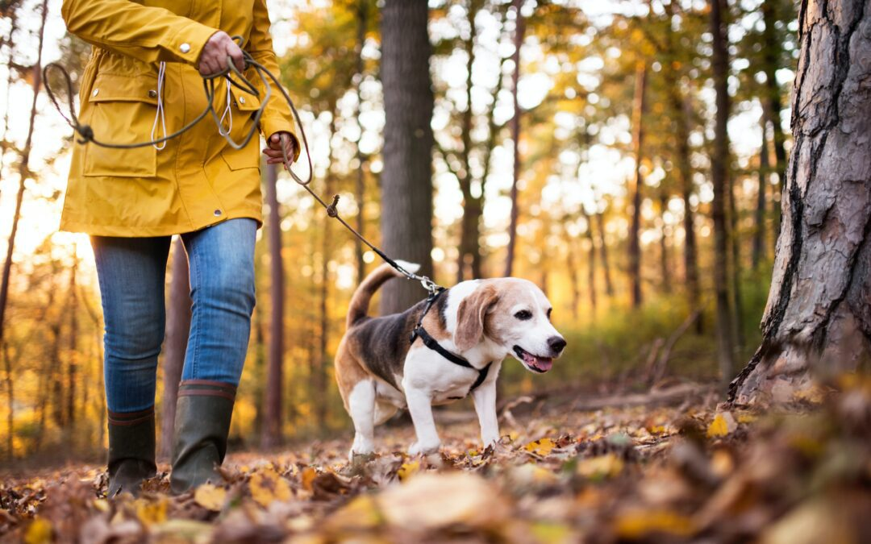
Keeping Senior Pets Happy During Holiday Season
As the holiday season approaches, our hearts fill with excitement and joy. It’s a time for festivities, family gatherings, and spreading cheer. Our pets, especially our senior companions, are integral to this celebration. Their golden years should be filled with love, comfort, and happiness. Let’s delve into how we can ensure our senior pets enjoy the holiday season fully.

Comfort and Familiarity
Change can be unsettling for senior pets. During the holiday hustle and bustle, they maintain their daily routine and keep their environment familiar. Ensure their bed, food, and water bowls are in their usual spots, providing them security.

Mindful Feasting
Indulging in festive feasts is a hallmark of the holiday season. However, be cautious about what your senior pet consumes. Some holiday treats may not sit well with their sensitive digestive systems. Stick to their regular diet, and if you’d like to treat them, opt for pet-friendly holiday goodies in moderation.

Gentle Exercise and Play
Encourage light exercise and playtime tailored to your senior pet’s abilities. Engage them in activities that they enjoy, promoting mobility and mental stimulation. A short walk or a favorite toy can bring immense joy.

Cozy Comfort
The winter chill can be harsh, especially for our senior fur babies. Provide them with cozy bedding and, if needed, a warm sweater to keep them comfortable. Ensure they have a warm and draft-free place to rest.

Quiet Retreats
With the influx of guests and noise during the holidays, create a peaceful retreat for your senior pet where they can relax and unwind. Let them retreat to a quiet room if the celebrations become overwhelming.

Regular Vet Checkups
Above all, prioritize your senior pet’s health during this season of love and care. Regular veterinary checkups are vital to monitoring their well-being.

In conclusion, the holiday season is about creating beautiful memories with loved ones, including our cherished senior pets. We can ensure their happiness and well-being by providing them with a comfortable, familiar environment, mindful nutrition, and regular affection. Remember, their health matters the most. Contact us today if you have any concerns or need guidance on keeping your senior pet joyful and healthy during the holiday season.

