It’s Raining Puppies!
by Hillside Animal Hospital | Feb 11, 2022 | Blog

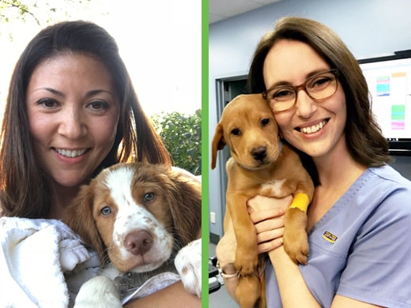

Did you know that by 4 months of age, 80% of your puppy’s brain has already developed to maturity? That means they have already formed a variety of associations with their surroundings and the people and objects within them. This is why socializing your young puppy in a safe and controlled environment is so important. The prime time to do this is between 8-16 weeks of age. During this time frame, they are taking in the most stimuli from their environment and deciding what they do and do not like. If they have negative experiences, it can set them up for fear and anxiety later in life. For this reason, I am excited to announce that I have teamed up with a local trainer for puppy socialization classes at Hillside Animal Hospital.
Sarah Hoth, the owner of the Persuaded Pooch, is a KPA-CTP and Fear Free Certified trainer in the St Louis area. She has extensive knowledge of canine behavior and learning and has turned this passion into a successful dog training business. Sarah has worked with service and therapy dogs, as well as helping owners with their pet’s obedience challenges. She achieves this using positive reinforcement methods. This training approach has been proven to not only gain better long-term results but also help strengthen the bond between you and your pet. She continues to expand her knowledge by attending seminars and classes throughout the year.
For those of you who don’t know me, I am Carolyn a Registered Veterinary Technician at Hillside Animal Hospital. While I enjoy the medical side of my job, I’ve always been drawn to the behavior field. I offer behavior consultations at Hillside in conjunction with our doctors and attend meetings and conferences with an emphasis on behavior throughout the year. I am thrilled to have obtained the highest level of Fear Free Certification and plan on obtaining other behavior-related certifications. I am also proud that Hillside was the first hospital in St Louis City, the 22nd nationally, to become a Fear Free Certified Practice. We worked hard for this distinction and are excited to see our patients respond to our new ways of making vet visits fun. For more information about Fear Free visit Fear Free Happy Homes.
Now that you know a little about Sarah and myself, let me tell you about our classes. After our start date was delayed due to weather, we were excited to finally hold our first group of puppies on January 26th. These courses are designed to introduce your puppy to new people, other puppies, sounds, and objects. Each class focuses on basic training skills as well as exposure to different stimuli. We are accepting all eligible puppies on a rotating basis, meaning that enrollment is always open. All puppies must be between the ages of 8-12 weeks at the time of registration, up to date on vaccinations, and healthy. We also offer a promotion for established Hillside clients. For more information, or to register your pup, see the persuadedpooch.com.
The socialization process is never-ending. Since puppies spend the majority of their time at home, we strongly urge our pet parents to continue the process outside the class setting. We like to think of it as vaccinating your puppy against behavior problems in the future. You have the opportunity to set your pup up for success with continual and safe exposure to people, places, and other pets. However, if you notice them displaying fear in any situation, you should seek guidance from a veterinary professional. If you have any further questions, please feel free to contact us at Hillside Animal Hospital. We look forward to meeting you and your new puppies!

