In the Hotseat: Drs. Anna & Aaron
by Hillside Animal Hospital | Feb 11, 2022 | Blog

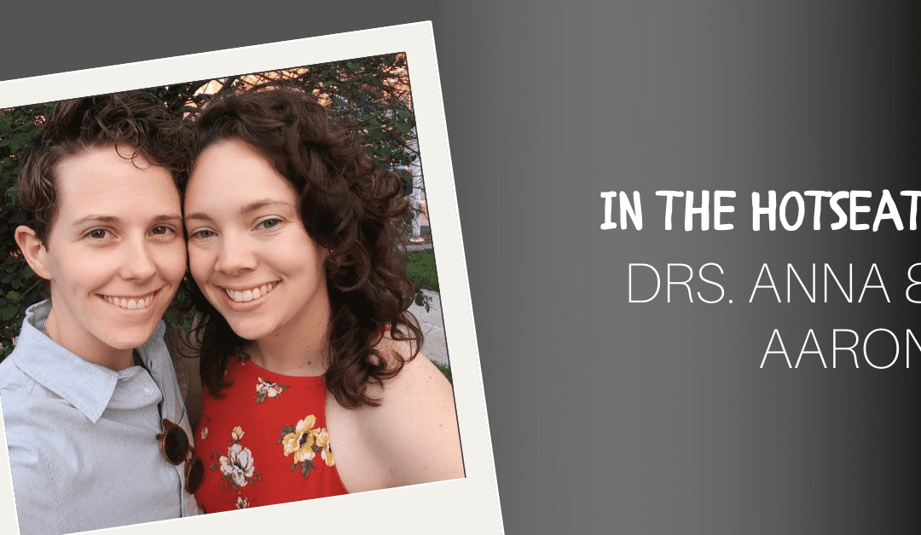

As some may be aware, as of January 1, 2020, Hillside Animal Hospital is under new ownership. This is a very exciting time, as we announce Drs. Anna and Aaron as our new practice owners! Our goal with this Q&A, was to allow you, our dedicated clients, to get to know them on a different level.
Question: Where did you attend vet school?
Dr.’s Anna and Aaron: University of Missouri- Columbia
Question: How long have you been in practice?
Dr.’s Anna and Aaron: 6 years this May
Question: At what age did you know you wanted to be a vet?
Dr. Anna: My interest started when I was very young, and I would stand on a chair in a cap, mask, and gown and watch my dad perform surgery. I grew up in the animal hospital and never thought about doing anything else.
Dr. Aaron: 5 or 6 years old
Question: What is your favorite medical instrument?
Dr. Anna: My stethoscope! I love listening to hearts and lungs. Cardiology is so fascinating to me! You can gain so much information about the heart just by listening to it.
Dr. Aaron: 1. Ophthalmoscope- because eyes are so cool! 2. Scalpel blade or electrocautery- because I love performing surgery to cure a patient!
Question: What are your hobbies outside of veterinary medicine?
Dr. Anna: I love hiking with my wife and my dogs, going to the movies, and trying new restaurants.
Dr. Aaron: hiking, traveling, cooking, and gardening
Question: Why do you love working at Hillside?
Dr’s Anna and Aaron: We love working at Hillside for so many reasons! We have an excellent staff who are dedicated to client education and patient care. Everyone at Hillside Animal Hospital has a desire for knowledge and we all work together to provide the highest quality treatment for our patients. Also, we have fantastic clients who care for their pets and trust us to help them to the best of our abilities. It is an honor to be a trusted member of a pet’s care team and we really value the relationships that we have with our clients. However, the best part of our job is the ability to improve a patient’s life! It is always rewarding to see a patient who has become more confident at the vet because of our Fear Free practices.
Question: What are you looking forward to most as new practice owners?
Dr.’s Anna and Aaron: We are really looking forward to getting to know our clients better and continuing to foster relationships with our patients. We are excited to guide Hillside’s growth and to continue to offer excellent care to our patients.
Question: Where do you see Hillside at in 5 years?
Dr.’s Anna and Aaron: Hillside Animal Hospital has a bright future! We are excited to continue to offer excellent and compassionate care to our patients and their owners. Some of our future goals include becoming a certified Low Stress Handling veterinary practice, improving quality of life and care for our senior and geriatric patients, and expanding our services to allow for rehabilitation and physical therapy.
​
Additionally, we want to become more connected to our community and participate in programs that aid clients with financial needs or difficult circumstances that make pet ownership more difficult. We have always enjoyed our work with rescue organizations and are looking forward to fostering more of those relationships.
–Written by Jayme Martin, Hillside RVT

