Hillside Enrolls in AVMF’s Veterinary Charitable Care Program
by Hillside Animal Hospital | Feb 11, 2022 | Blog
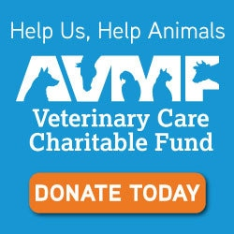
Hillside Animal Hospital’s veterinarians and staff are happy to announce that they recently enrolled in the American Veterinary Medical Foundation’s Veterinary Care Charitable Fund.
This program was created to support veterinarians who provide medical services to the lost, neglected, and abused animals that find their way into our hospital. The program also allows us to care for animals in our community when their owners face extraordinary hardships.
By partnering with the AVMF’s fund, we’re able to offer supporters a tax-deductible, convenient way to donate and support our efforts to help pets in extreme need.
We invite you to support us in this new endeavor by making a donation to the AVMF to support our charitable work. The AVMF is the charitable arm of our professional membership organization, the American Veterinary Medical Association. The AVMF has been helping veterinarians help animals for more than 50 years.
Your tax-deductible donations to the AVMF on behalf of our hospital will help us help animals. Click on the AVMF donate button to make your tax-deductible donation today!
Thank you in advance for your donation. All gifts, no matter the size, are greatly appreciated. Please watch for additional messages that will share exciting and heartwarming stories of the animals that are helped through your generosity.

