Happier Pets Are Healthier Pets
by Hillside Animal Hospital | Feb 11, 2022 | Blog

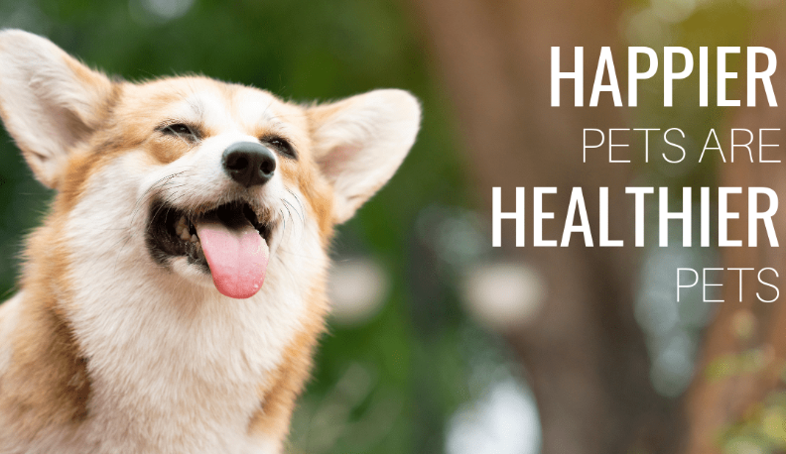
Stress – we all experience it when going to our doctor. Our heart races, blood pressure rises, and we just want to get it over with. While we can express our fears and anxieties to our health professionals, our pets cannot. In fact, a 2014 study conducted by Bayer Veterinary Healthcare showed that 37% of dog owners and 58% of cat owners believe that their pet hates veterinary visits. They have witnessed their pet being fearful, or in some cases become aggressive, because they are afraid of the exam process. When the pet’s stress level increases, the physical exam not only becomes more difficult to perform but their vital signs and blood tests can be affected by rising levels of the stress hormone called cortisol. Watching their furry friend go through anxiety-inducing events will often deter pet parents from scheduling annual visits in the future. Without routine veterinary care, many issues may go undetected for long periods of time, having detrimental effects on their pet’s health. Fortunately, there are certifications for veterinarians and staff that are changing the way we handle our patients. This helps make the process less stressful for everyone involved, resulting in happier visits and better care for our patients.
Fear Free Certification
Fear Free was developed in 2016 by Dr. Marty Becker, a veterinarian who wanted to educate other veterinary professionals in recognizing and handling fearful animals. Currently, there are three levels of individual certifications as well as a hospital certification. As many of you know, Hillside Animal Hospital has embraced this movement and became the 22nd hospital in the country to achieve the clinic certification in 2018. The majority of our staff has achieved or is in the process of achieving Level 3 credentials. We have completed over 22 hours of online classes each, designed to teach us how to recognize anxiety in our patients and adjust our techniques in ways to decrease the fear they are experiencing. We do not condone the old methods of forceful restraint or scruffing. You will notice that we will use lots of treats and gentle handling techniques to make the visits much more pleasant. We also offer Happy Visits free of charge to help your pet make better associations with our hospital. In some cases, the techniques we use are still not enough to help reverse the damage done by years of anxiety. In those instances, we may be able to offer anti-anxiety medications for future visits to help your pet become relaxed.
Cat Friendly Practice Program
In addition to Fear Free, Hillside also became a certified Cat Friendly Practice in 2018. This program was established by the American Association of Feline Practitioners (AAFP) and the International Society for Feline Medicine (ISFM). Much like Fear Free, it focuses on recognizing fear and anxiety in our feline patients. We have set up a designated Cat Waiting area as well as a cat-only exam room. Within the areas, you will hear soothing sounds, smell relaxing lavender being diffused, and see Feliway infused towels and plug-in diffusers emitting the calming pheromone. All of these, combined with using gentle handling techniques, are designed to help your cat feel more relaxed and therefore more comfortable during the exam process.
Low Stress Handling Certification
Low Stress Handling Certification was established in 2014 by Dr. Sophia Yin. The late veterinarian was a pioneer in the behavioral field of veterinary medicine. After her death, Dr. Sally Foote recognized its importance and continued Dr. Yin’s legacy by establishing Low Stress Handling University. The Silver Certification level requires students to complete 20 hours of online lectures and labs, as well as multiple quizzes and a final exam. The coursework offers extensive education on the fundamentals of behavior and learning theory, as well as teaching veterinarians and their staff to understand their patients’ emotional states and how to apply skills to handle them in a less stressful way. One of the most recognizable methods is her cat towel wraps. There are several variations of these wraps, all of which help cats feel more secure and allow for less restraint during the exam. As of now, I am the only individual who is Low Stress Handling Silver Certified, though many other staff members are soon to follow. Once we have a minimum of 51% of our team members certified, we are planning on applying for the Low Stress Hospital Certification.
As you can see, the staff at Hillside Animal Hospital is committed to a well-rounded approach to medicine. We believe that addressing both the physical and mental health of our patients allows us to provide better care for your pet. Because we want your pets to feel at ease during their visits, we encourage open communication about what your pet does and does not like. If your dog or cat doesn’t like a particular part of the exam process, please let us know so that we don’t cause any additional stress. We consider our pet parents to be part of the team and want you to participate in your pet’s visit. Please bring treats, toys, or anything that they enjoy. If they are nervous about car rides, carriers, or other triggers prior to entering our hospital, please let us know. There are ways you can help ease their stress at home and along the way to the clinic to see us.
If you would like more information about the certifications mentioned above, please visit the following websites:
fearfreepets.com
catvets.com
lowstresshandling.com
– Carolyn Torno, RVT, Fear Free Certified Professional Level 3, Low Stress Handling Certified Silver

