FNAs ASAP!
by Hillside Animal Hospital | Feb 11, 2022 | Blog

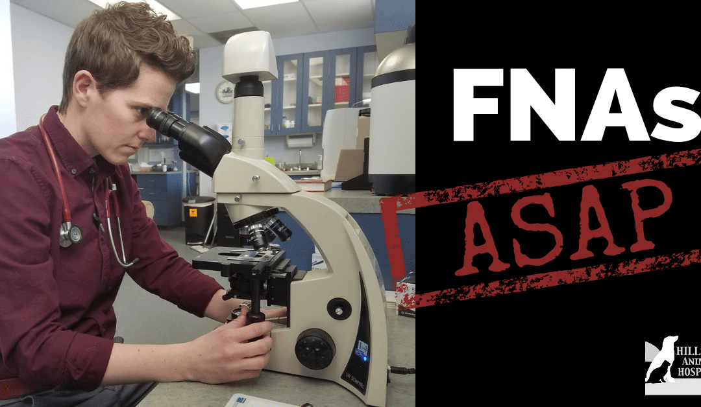

When our veterinarians ask you if we can perform a fine needle aspirate on your pet what we should say is, “We need an FNA ASAP.” FNAs (or fine needle aspirates) are a diagnostic tool that we can use in our office, for a relatively low cost. They can give us important answers to the new lump that you found on Fido. Fine needle aspirates are performed very quickly in the exam room. The procedure involves inserting a needle into a growth either on or just below the skin in the subcutaneous area. When we pull back on the syringe either fluid or just a few cells are “aspirated” out of the lump. We then plunge the syringe and the contents are expelled onto a clear glass slide. The slide is then stained and dried so that we can examine the cells under the microscope.
What we see under the lens (cytology) can either give us a slight clue or a definitive diagnosis of what the lump may be. There are a handful of tumors that we can say what they are, right then and there, such as lymphoma and mast cell tumors. In these cases, it is very important to start treatment right away to give Fido the best prognosis. There are also many cases where FNAs are just one step in the diagnostic tree. They can provide enough information for us to recommend whether or not additional diagnostics and/or treatments are needed. We may recommend surgical removal of the lump followed by biopsy (tissue sent to the lab for a definitive diagnosis or staging of the lump). We may recommend chemotherapy or radiation to reduce the size of the tumor. We also may recommend leaving the tumor alone and monitoring it for changes in size, texture, or shape.
The knowledge we gain from this simple test could save Fido’s life, that’s why we always recommend performing FNAs ASAP.

