Caring for Pandemic Pups and Covid Cats
by Hillside Animal Hospital | Feb 15, 2022 | Blog
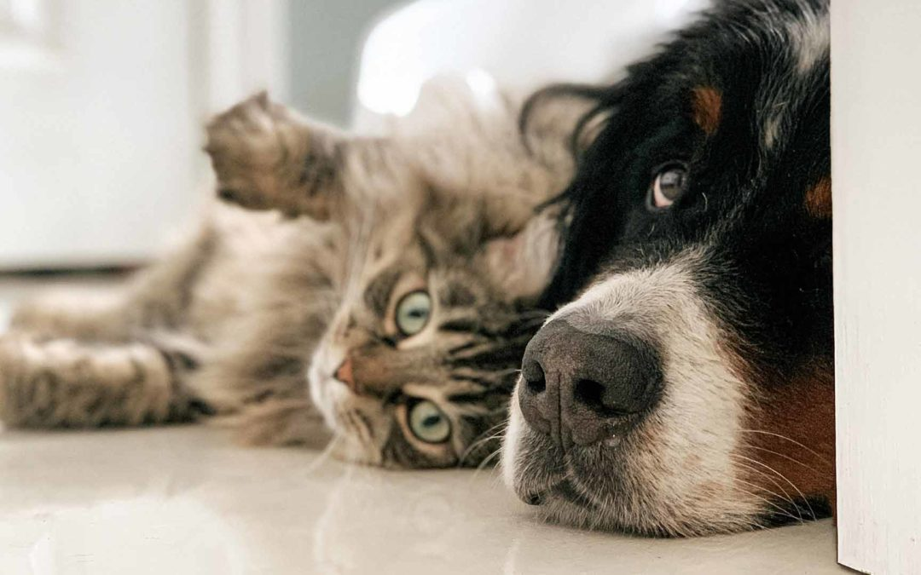
It’s 2020 and you were preparing to make it a great year. 2019 was a thing of the past and you were going to make 2020 a great year!…. Then a few months into the year the world shut down. Covid 19 had become a global pandemic. People were forced to work from home, social distance, and mask up for everyone’s protection. This was an introvert’s dream and an extrovert’s nightmare. You worked from home answering calls, operating via your computer, and handled Zoom meetings for you and your kids. Maybe your work attire was pajamas, your makeup collected dust, or you worked up the courage to finally grow that beard. Unfortunately, we are social creatures and we seek companionship so you thought why not adopt a pet to keep you company?! You got your furry friend and they kept you company while you worked. This was the best thing to happen to both of you….until the world slowly opened back up.

You aren’t the only one stressed by social distancing…
Once people started going back to work there was a rise in behavior issues and anxiety in young dogs and cats adopted during the pandemic. Animals started to show signs of separation anxiety. This is when they show signs of distress after being separated from their preferred people. These signs can be vocalizing, excessive salivation, destructive behavior, inappropriate elimination, and self trauma like licking or chewing on themselves. These animals have gone from having their preferred people around almost 24 hours a day to them being missing for 8 to 10 hours at a time. If your new furry friend is showing signs of anxiety there are things you can do. You can reach out to a trainer to get tips on how to comfort your pets at home. This can be done by training them to have a safe spot like a bed or kennel to rest in and where they feel comfortable. Also you can start practing leaving without making a big deal out of it. Simply start by grabbing your things and walking out the door for a few minutes and then come back in and set your things down. Repeat this until there is very little response from your pets. Gradually increase the length of time you do this and work up to small errands with the goal of having a full day of work without stress or anxiety. You can also reach out to your veterinarian if the anxiety is severe enough for medication or supplements. You can start with simple things such as pheromone collars or diffusors or even supplements that help with anxiety. For more severe cases anti-anxiety medicatons may be needed. With a few of these tips and tricks you can combat anxiety and stress in your pets and help them cope with your change in schedule.

The “Covid 19” isn’t just a human issue….
Isolating at home during the pandemic kept many people indoors and often their pets as well. It became all too easy to lounge around snacking most of the day. This meant people stopped walking their dogs, playing with their cats, and over rewarded with treats and extra food. Who wouldn’t want to reward their dog from laying at their feet all day while they worked or pour a bigger bowl of fod for their cat just to keep them off your keyboard? Seeing our furry friends everyday can make it hard to realize that their weight is slowly creeping up. This problem can be addressed in a few ways. We can start by feeding our pets an adequate amount of food. Using an actual measuring cup and feeding 10-15% less that the recommended amount on the bag of food is a great place to start. Treats can be replaced with lower calorie options like carrots or green beans. You can even uses pieces of food, just make sure to subtract it from their daily amount. It is often the act of getting a treat and not the treat itself that animals love. Exercise is also important for both ends of the leash. You can start by walking your dog or playing with your cat. Walks with your dog should be brisk and shouldn’t be a “shuffle and sniff fest”. You can use a variety of toys or feeding/treat balls with your cat. Small balls or feather/string toys are also fun options for cats. Incorporating a few of these suggestions can help keep you and your pets healthy.

Can my pets give me a plague?….
Finally, one big concern among pet owners is ” Can my pets get or give me Covid”? Currently only a few companion animals have been infected with Covid after being around people that had the virus. These animals showed no symptoms and this can happen with any virus. Sometimes viruses can infect a species, but not cause illness or be transmissible to others. Also, your pets will not pass Covid to you and are not considered a source of infection for the virus. As with all interactions with animals it is recommended that you use good sanitary habits such as handwashing after handling animals especially before preparing or eating food.
Hopefully this helps provide some insight into how to care for your “Pandemic Pups” and “Covid Cats”. We are all social creatures and the human-animal bond has been shown to help us physically and mentally. In times of stress, like a pandemic, we must lean on each other for support. Sometimes your support just so happens to have a wet nose or a tail. Stay safe and healthy!

